**CMSC 451 Homework 4**

Consider the following directed graph for each of the problems:

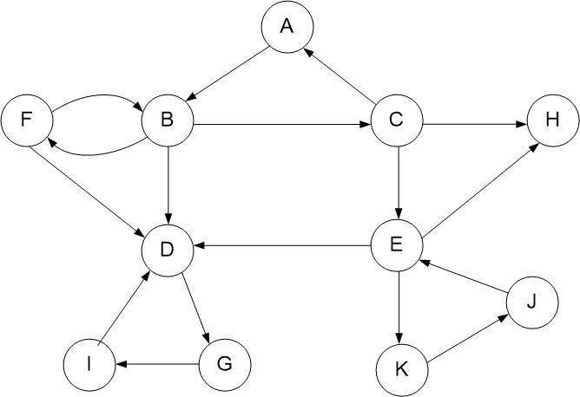

1. Perform a breadth-first search on the graph assuming that the vertices and adjacency lists are listed in alphabetical order. Show the breadth-first search tree that is generated.

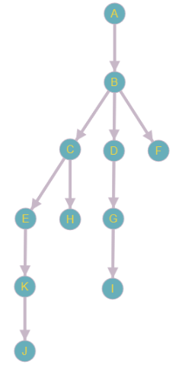

1. Perform a depth-first search on the graph assuming that the vertices and adjacency lists are listed in alphabetical order. Classify each edge as tree, forward, back or cross edge. Label each vertex with its start and finish time.

Tree Edge

Back Edge

Forward Edge

* No Cross Edges

11/12

3/18

1/22

2/21

19/20

7/8

6/9

13/16

14/15

5/10

4/17

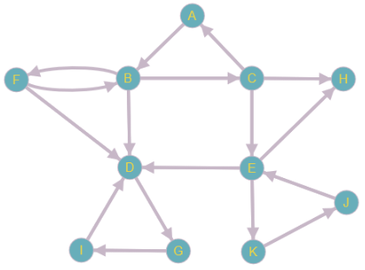

1. Remove all the back edges from the graph so it becomes a DAG. Perform a depth-first search recording the start and finish times. Using those finish times, provide the topological order that is produced. Provide one breadth-first topological order for that graph.

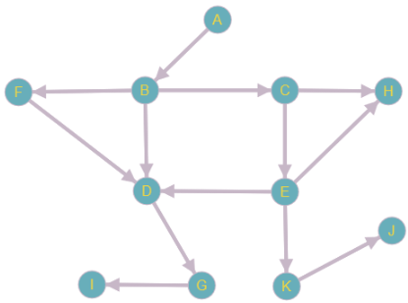

13/16

7/8

1/22

11/12

4/17

5/10

6/9

14/15

2/21

3/18

19/20

Enumerating the vertices as they finish we get the following enumeration:

**I G D H J K E C F B A**

If we reverse the above enumeration we get the following depth-first topological order:

**A B F C E K J H D G I**

One possible resulting breadth-first topological order is the following:

**A B F C E H D G K I J**

1. Determine the strongly connected components of the graph using the algorithm provided in the sample problems. Show the final depth-first search of the transpose graph labeled with its start and finish times. Identify the strongly connected components based on that search.

Depth-First Topological Order from Problem #3:

**A B F C E K J H D G I**

SCCs = {A, B, F, C}, {E, K, J}, {H}, {D, G, I}

Transposed Graph:

Tree Edge

Back Edge

3/6

4/5

2/7

1/8

15/16

11/12

10/13

18/21

19/20

17/22

9/14

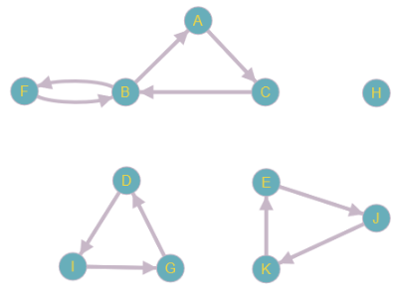

**Grading Rubric**

|  |  |  |  |  |  |  |  |
| --- | --- | --- | --- | --- | --- | --- | --- |
|  | **Problem** |  | **Meets** |  |  | **Does Not Meet** |  |
|  |  |  | **10 points** | |  | **0 points** |  |
|  |  |  |  | |  |  |  |
|  |  |  |  | |  |  |  |
|  |  |  | Breadth-first search was done correctly | |  | Breadth-first search was not done |  |
|  | **Problem 1** |  | assuming alphabetical vertex and | |  | correctly assuming alphabetical vertex |  |
|  |  |  | adjacency lists (5) | |  | and adjacency lists (0) |  |
|  |  |  |  | |  |  |  |
|  |  |  | Tree provided is a correct breadth-first | |  | Tree provided is not a correct breadth- |  |
|  |  |  | search tree (5) | |  | first search tree (0) |  |
|  |  |  |  | |  |  |  |
|  |  |  | **10 points** | |  | **0 points** |  |
|  |  |  |  | |  |  |  |
|  |  |  |  | |  |  |  |
|  |  |  | Performed a correct depth-first search | |  | Did not perform a correct depth-first |  |
|  |  | (3) | |  |  | search (0) |  |
|  |  |  |  | |  |  |  |
|  | **Problem 2** |  | Tree edges correctly labeled (1) | |  | Tree edges not correctly labeled (0) |  |
|  |  |  |  |  |  |  |
|  |  | Back edges correctly labeled (1) | |  | Back edges not correctly labeled (0) |  |
|  |  |  |  |  |
|  |  |  |  | |  |  |  |
|  |  |  | Forward edges correctly labeled (1) | |  | Forward edges not correctly labeled (0) |  |
|  |  |  |  | |  |  |  |
|  |  |  | Cross edges correctly labeled (1) | |  | Cross edges not correctly labeled (0) |  |
|  |  |  |  | |  |  |  |
|  |  |  | Provided correct start and finish times | |  | Did not provide correct start and finish |  |
|  |  | (3) | |  |  | times (0) |  |
|  |  |  |  | |  |  |  |
|  |  |  | **10 points** | |  | **0 points** |  |
|  |  |  |  | |  |  |  |
|  |  |  |  | |  |  |  |
|  |  |  | Correctly transformed the graph into a | |  | Did not correctly transform the graph |  |
|  |  |  | DAG (2) | |  | into a DAG (0) |  |
|  |  |  |  | |  |  |  |
|  | **Problem 3** |  | Provided correct start and finish times | |  | Did not provide correct start and finish |  |
|  | (3) | |  |  | times (0) |  |
|  |  |  |  |  |
|  |  |  |  | |  |  |  |
|  |  |  | Provided correct topological order | |  | Did not provide correct topological |  |
|  |  |  | from finish times (3) | |  | order from finish times (0) |  |
|  |  |  |  | |  |  |  |
|  |  |  | Provided correct breadth-first | |  | Did not provide correct breadth-first |  |
|  |  |  | topological order (2) | |  | topological order (0) |  |
|  |  |  |  | |  |  |  |
|  |  |  | **10 points** | |  | **0 points** |  |
|  |  |  |  | |  |  |  |
|  |  |  |  | |  |  |  |
|  |  |  | Correctly transposed graph (2) | |  | Did not correctly transpose graph (0) |  |
|  |  |  |  | |  |  |  |
|  | **Problem 4** |  | Provided correct start and finish times | |  | Did not provide correct start and finish |  |
|  |  | (4) | |  |  | times (0) |  |
|  |  |  |  | |  |  |  |
|  |  |  | Provided correct strongly connected | |  | Did not provide correct strongly |  |
|  |  |  | components (2) | |  | connected components (0) |  |
|  |  |  |  |  |  |  |  |